**Demo1 -Using L298N module to drive the chassis**

**Table**

1. Preface 1

2. Component/Module List 1

3. Component related knowledge 3

3.1Knowledge of the TT Motor 3

3.2 Knowledge of L298N Motor driver module 4

4. Circuit connection 6

5. Upload code and test 8

6. Make your suggestion and get support 8

# Preface

Our final form of this product is a small car chassis with one servo, 2 motors and 4 wheels, without motor drive modules, control boards, batteries, and other things. Its highlight lies in its development and scalability. You can choose the motor drive and control board you want to use, install it on the chassis of this car, and make it run. This will be a challenging and fulfilling task. Wishing you success!

You can also refer to our Demo1, where we assembled 1pcs L298N motor module, Arduino UNO R3, and 2pcs 18650 batteries onto the chassis of the car, creating a car based on Arduino. The following Lesson will provide a detailed introduction to Demo1, including component list, component related knowledge, circuit connection, code, and more. If you are interested in Demo1, you can refer to the Demo1 checklist to prepare relevant materials for experimentation.

If you have any technical issues or suggestions, please provide feedback to us via email: **[cokoino@outlook.com](mailto:cokoino@outlook.com)**

# Component/Module List

For this Demo1 experiment, what do you need to prepare like below list

|  |  |  |  |
| --- | --- | --- | --- |
| Component/Module | QTY | Picture | Remark |
| Real-Wheel Drive Steering Car Chassis | 1 |  | Provided by the Real-Wheel Drive Steering Car Chassis Kit,you need assembled by yourself |
| UNO R3 Board | 1 | UNO | Not included in this Kit  You need to prepare these by yourself. |
| L298N Motor driver module | 1 |  |
| 18650 battery | 2 |  |
| Male to Male Dupont wire | 5 | 公对公杜邦线 | Not included in this Kit  You need to prepare these by yourself. |
| Male to Female Dupont wire | 6 | 公对母杜邦线 |

# **Component related knowledge**

## **3.1Knowledge of the TT Motor**

As shown in the figure below, the TT motor consists of a DC motor and related gears, with a yellow outer shell fastened.

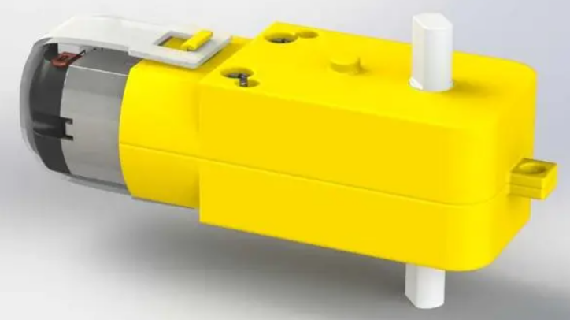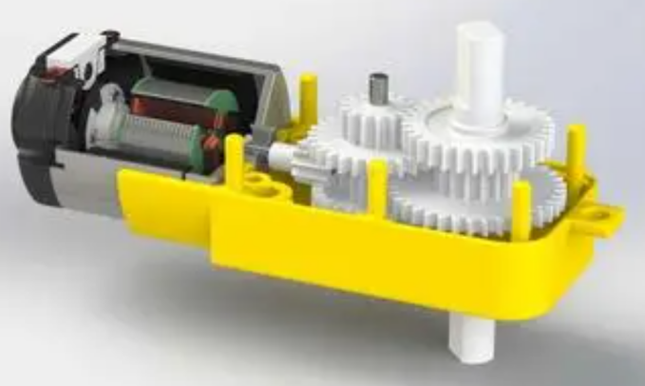

**DC Motor**

When motor is connected to the power supply, it will rotate in one direction. Reverse the polarity of power supply, the motor will rotate in the opposite direction.

And the speed of motor depends on the voltage between two ends. The larger the voltage, the lager the speed.

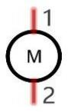

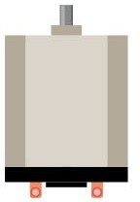

PWM

PWM, Pulse Width Modulation, uses digital pins to send certain frequencies of square waves, that is, the output of high levels and low levels, which alternately last for a while. The total time for each set of high levels and low levels is generally fixed, which is called the period (the reciprocal of the period is frequency). The time of high level outputs are generally called “pulse width”, and the duty cycle is the percentage of the ratio of pulse duration, or pulse width (PW) to the total period (T) of the waveform.

The longer the output of high levels last, the larger the duty cycle and the higher the corresponding voltage in analog signal will be. The following figures show how the analogs signal voltage vary between 0V-5V (high level is 5V) corresponding to the pulse width 0%-100%:

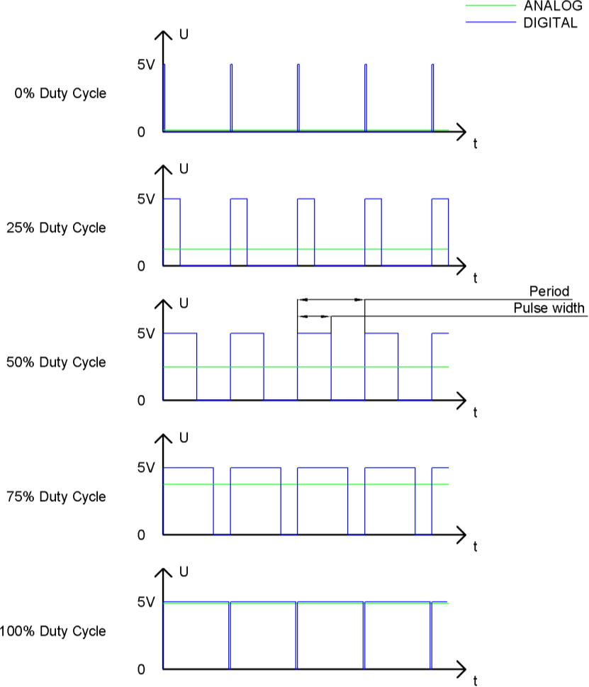

The longer the PWM duty cycle is, the higher the output power will be. Now that we understand this relationship, we can use PWM to control the brightness of an LED or the speed of DC motor and so on.

 GND GND 

## 3.2 Knowledge of L298N Motor driver module

L298N is a specialized driver integrated circuit, belonging to H-bridge integrated circuits. Its output current is 2A, with a maximum current of 4A and a maximum working voltage of 50V. It can drive inductive loads such as high-power DC motors, stepper motors, solenoid valves, etc. Especially, its input end can be directly connected to the microcontroller, making it easy to be controlled by the microcontroller. When driving a DC motor, the stepper motor can be directly controlled and the forward and reverse rotation of the motor can be achieved. To achieve this function, only the logic level of the input terminal needs to be changed. In order to avoid interference from the motor on the microcontroller, an optocoupler is added to this module for photoelectric isolation, so that the system can work stably and reliably.

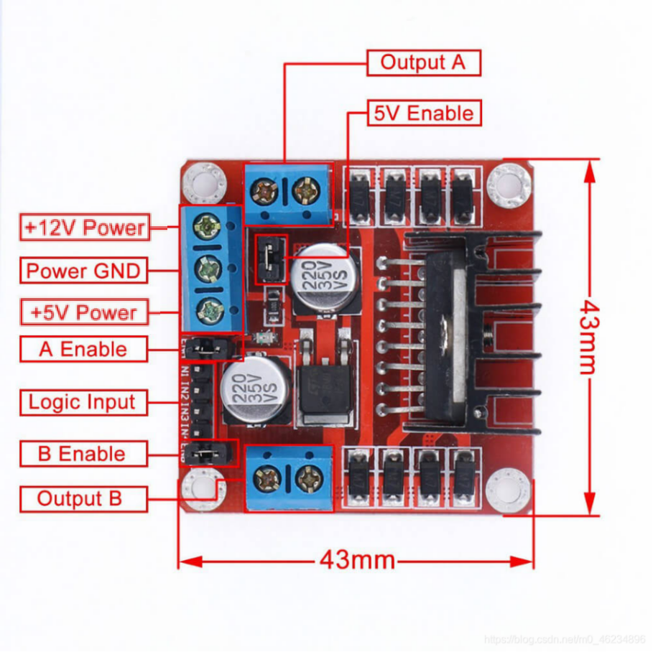

**Output A**: Connect A+and A - of DC motor 1 or stepper motor;

**Output B**: Connect B+and B - of DC motor 2 or stepper motor;

**5V Enable**: If using a power supply with an input voltage greater than 12V, please remove the jumper cap. When the input power is less than 12V, short circuiting can provide 5V power output;

**+5V Power**: When the input power is less than 12V and 5V Enable is in a short circuited state, it can provide+5V power output; (Please refer to the markings on the driver board for actual location)

**GND**: power ground;

**+12V Power**: Connect the motor power supply, maximum 35V. When the input voltage is greater than 12V, to ensure safety, please remove the jumper cap on the 5V Enable pin; (Please refer to the markings on the driver board for actual location)

A/B Enable: can be used to input PWM pulse width modulation signals for speed control of motors. If there is no need to adjust the speed, the two pins can be connected to 5V to make the motor work at the highest speed, which is achieved by short circuiting the short-circuit cap. It is easier to achieve forward and reverse rotation of the motor. The input signal terminal IN1 is connected to the high-level, input terminal IN2 is connected to the low-level input terminal, and the motor M1 rotates forward. (If the signal terminal IN1 is connected to a low level, IN2 is connected to a high level, and motor M1 is reversed.) Control another motor in the same way, with the input signal terminal IN3 connected to a high level, input terminal IN4 connected to a low level, and motor M2 rotating forward. (On the contrary, it will be reversed), PWM signal terminal A controls M1 speed regulation, and PWM signal terminal B controls M2 speed regulation. You can refer to the following chart:

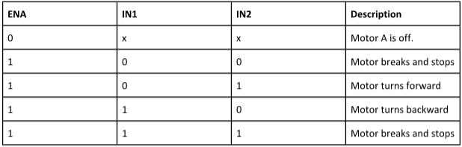

Parameters:

1. Driver chip: L298N dual H-bridge DC motor driver chip

2. The power supply range of the driving part terminals is Vs:+5V -+35V;

If it is necessary to take power from the board, the power supply range is Vs:+7V -+35V

3. Peak current of the driving part Io: 2A

4. Logic section terminal power supply range Vss:+5V~+7V (can be powered on board+5V)

5. Operating current range of logic part: 0-36mA

6. Control signal input voltage range:

Low level: -0.3V ≤ Vin ≤ 1.5V

High level: 2.3V ≤ Vin ≤ Vss

7. Enable signal input voltage range:

Low level: -0.3 ≤ Vin ≤ 1.5V (invalid control signal)

High level: 2.3V ≤ Vin ≤ Vss (effective control signal)

1. Maximum power consumption: 20W

# Circuit connection

Assemble the chassis according to Lesson 3, then fix the Arduino UNO R3 board in the development board assembly area of the chassis with 2 M3 * 10mm round head screws, and fix the L298N module on the acrylic at the rear of the chassis with 2 M3 * 10mm round head screws The acrylic at the rear of the chassis has an expansion function, and its slot can match the installation of many types of modules.

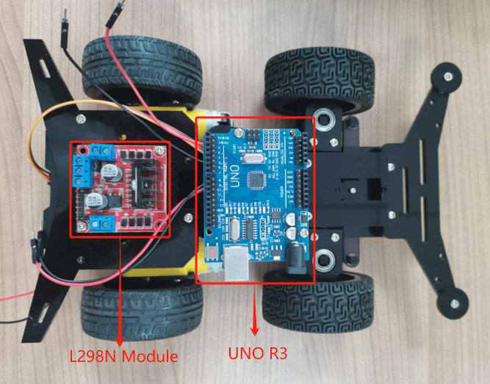

After assembling the UNO R3 and L298N modules, remove the short-circuit caps at the ENA and ENB positions on the L298N module.Let's connect the UNO R3 board to the L298N module using a suitable DuPont wire according to the following hardware connection table.

**Connection Description Table**

|  |  |  |  |
| --- | --- | --- | --- |
| **L298N module and MG90S Micro Servo corresponding connection to UNO R3 Board** | | | |
| UNO R3 Board Pins | L298N Module Pins | MG90S Micro Servo Pins | Connection tools |
| 2 | / | Signal | Male to male Dupont wire |
| 5 | ENB | / | Male to Female Dupont wire |
| 6 | ENA | / | Male to Female Dupont wire |
| 7 | N1 | / | Male to Female Dupont wire |
| 8 | N2 | / | Male to Female Dupont wire |
| 9 | N3 | / | Male to Female Dupont wire |
| 10 | N4 | / | Male to Female Dupont wire |
| VIN | +5V | / | Male to male Dupont wire |
| GND | GND | / | Male to male Dupont wire |
| GND | / | GND | Male to male Dupont wire |
| 5V | / | VCC | Male to male Dupont wire |

Connect the L298N module with the TT motors and 18650 battery box according to the following hardware connection table.

|  |  |
| --- | --- |
| **TT motor wires and 18650 battery box wires corresponding connection to L298N module** | |
| L298N Module Pins | TT motor wires and 18650 battery box wires |
| +12V | 18650 battery box red wire |
| GND | 18650 battery box black wire |
| OUT1 | Red wire of left rear wheel TT motor |
| OUT2 | Black wire of left rear wheel TT motor |
| OUT3 | Black wire of right rear wheel TT motor |
| OUT4 | Red wire of right rear wheel TT motor |

**Hardware connection diagram**

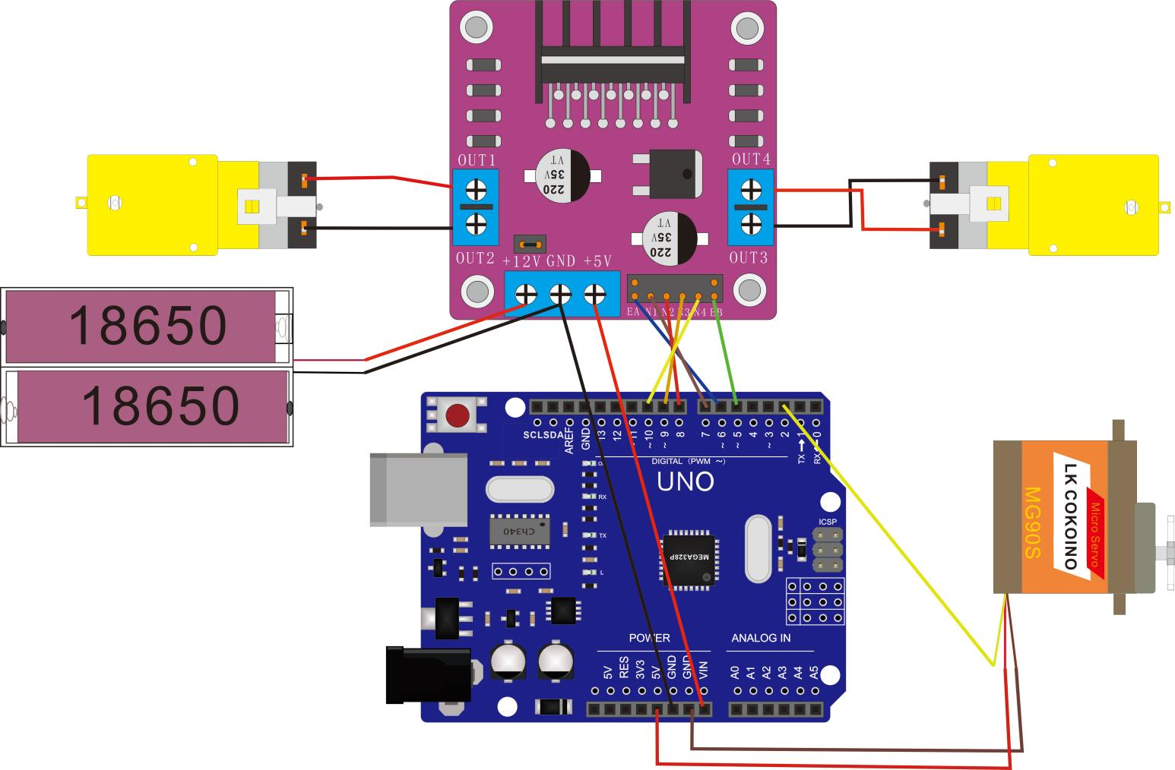

# Upload code and test

Click "File---"Open" in the IDE interface, and select the code under the path of "CKK0020-main\Tutorial\ Arduino\Sketches\ Demo1".

After the code is compiled successfully, connect the UNO board on the chaissis body to the computer with a USB cable, and upload the code.

After the upload is successful, Insert two fully charged 18650 batteries into the battery box.

The car will perform cyclic motion according to the motion logic set by the code. The motion logic set by the code is： forward for 2 seconds----stop for 1 second----backward for 2 seconds----stop for 1 second----move forward right for 0.5 seconds----stop for 1 second----move forward left for 0.5 seconds----stop for 1 second. You can modify the code according to your own needs to enable the car to achieve more complex and varied motion trajectories.

# Make your suggestion and get support

THANK YOU for participating in this learning experience!

If you find errors, omissions or you have suggestions and/or questions about this document, please feel free to contact us: **[cokoino@outlook.com](mailto:cokoino@outlook.com)**

We will make every effort to make changes and correct errors as soon as feasibly possible and publish a revised version.

If you want to learn more about Arduino, Raspberry Pi, Smart Cars, Robotics and other interesting products in science and technology, please continue to visit our Amazon Store by search for "LK COKOINO" on Amazon. Or visit our official website: [www.cokoino.com](http://www.cokoino.com)

We will continue to launch fun, cost-effective, innovative and exciting products.

Thank you again for choosing Cokoino products.

**LK COKOINO**